 H2Oil – Project

Join our community in this Online Platform to fight against Oil Spills. Make use of our multiple tools to share your knowledge with others and to make a difference!

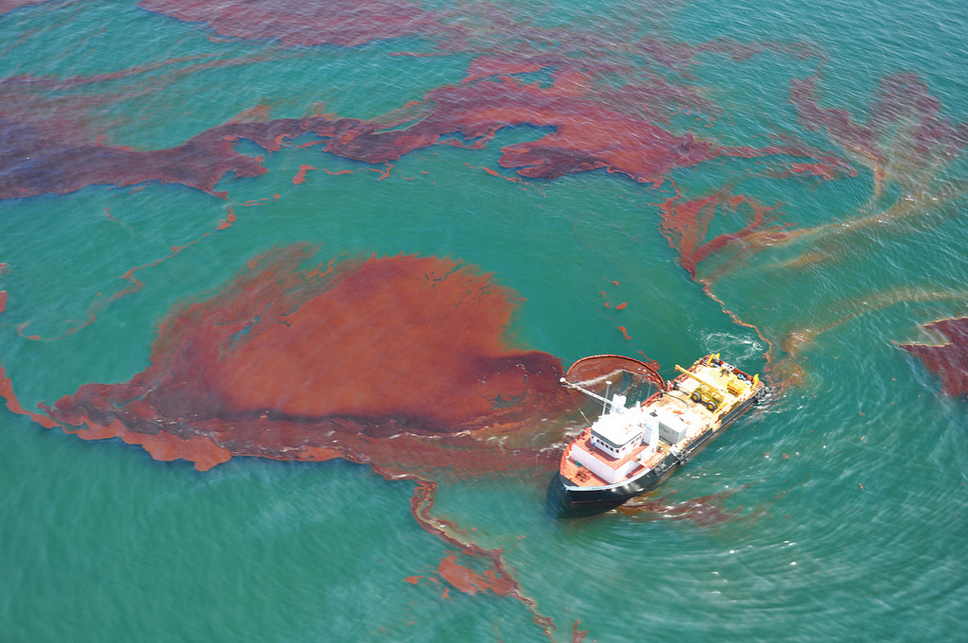

* Create and share posts to spread your experience;
* Interactive Map with the locations of Oil Spills;
* Contact with Oil Companies;
* Reporting System for potential Oil Spills;
* An updated News Feed.